Cold Chain
Dr. T. S. R. Peiris, Asst. Epidemiologist, Epidemiological Unit
Introduction:

The “cold chain” is the name given to a system of people and equipment which ensures that the correct quantity of potent vaccine reaches the women and children who need it from the point of production. The cold chain system is necessary because vaccines are delicate substances that lose potency if they are exposed to temperatures that are too warm or too cold. High levels of immunization coverage are useless if the vaccine that was used is not potent!

Figure I illustrates the entire cold chain system. There are many steps between the manufacturer of the vaccine and the woman or child in need of immunization. Vaccine must stay at the correct temperature throughout the entire cold chain system – when it is transported, when it is stored in a refrigerator or cold store, and when it is used at an immunization session.

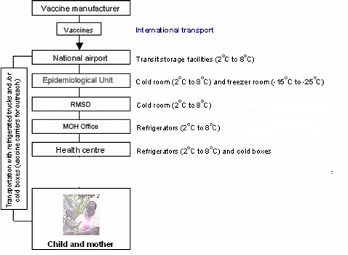

Figure 1

The two essential elements of cold chain system are:

- People to manage vaccine distribution
- Equipment to store and transport vaccine

People are an extremely important part of the cold chain. Even if the finest and most modern equipment is available, the cold chain will not be effective if people do not handle vaccine and equipment properly.

The basic cold chain equipment includes:

- For vaccine storage : Refrigerators, Freezers, and Cold-rooms.
- For vaccine transport: Cold boxes, Vaccine carriers, Day-carriers and Thermos flasks.
- For cold chain monitoring: Thermometers, Cold Chain Monitors, Vaccine Vial Monitors and Freeze Watch Monitors
- vehicles
Vaccine handling occurs mainly at four levels and at each level different members of the health team are responsible for the maintenance of cold chain as shown in the following table.

Level | Institution | Team Member
Central Level | Epidemiological Unit | Epidemiologist
District Level | Regional Medical Supplies Division (RMSD) | DPDHS, OIC/RMSD,RE, MO(MCH)
Divisional Level | Office of the Medical Officer of Health | MOH, PHNS, SPHM
Health Facility Level | Immunization Clinic | MOH, PHNS, SPHM, PHM, Nusing Officers and Pharmacists in Hospitals

Central Level

The required stocks of vaccine is ordered from abroad a year ahead.. The requirement is decided based on the population of the target age groups, previous year usage wastage and any special immunization programmes planned. All vaccines are imported from abroad. State Pharmaceutical Corporation (SPC) staff receive the stocks on arrival at the Air-port and transfer them to the Epidemiological Unit. At the Epidemiological Unit vaccines are in cold rooms and maintained at 2⁰C to 8⁰Cand -20⁰C. The vaccine stocks are distributed to Regional Medical Supplies Divisions (RMSD) every other month using cold boxes with well frozen ice packs.

Regional Medical Supplies Division (RMSD) level

DPDHS and officer in charge of the RMSD should obtain the stock return forms from all the institutions to which vaccines are distributed in the DPDHS Division, before the 5th of the month.
These returns should be checked for the following,

- the stocks requested are within reasonable limits.
- guidelines given to prepare the request has been followed.

The return could be adjusted in consultation with the MOH/ Head of the Institution. The consolidated vaccine distribution schedule for the district should be prepared in consultation with DPDHS, RE or MO (MCH). Consolidated return for the RMSD should be prepared based on the stock position and average vaccine requirement for the district . A copy of the consolidated return should be forwarded to the Epidemiologist by the 5th of the month whether the stocks are requested or not.
“Maximum stock” of any vaccine which should be in the store at the start of a new supply period at the RMSD, should not exceed 3 months stock of each vaccine.

The quantity of vaccine to be ordered should be calculated as follows:

The quantity of different vaccines currently in stock according to the registers should be noted. This should be checked with the actual stocks in hand. (These stocks should be the same)

The formula below will determine the quantity of vaccine or supplies to be ordered for the next supply period.

Maximum - Quantity = Quantity
Stock in stock to order

However this should be compared with the total quantity ordered by the MOOH/institutions in the area and adjusted if necessary. (eg. Vaccines for special immunization programmes).

Distribution of vaccine by RMSD

- Vaccine stocks should be distributed to Medical Officers of Health (MOOH) and Institutions in the DPDHS Division every month.

- Vaccines should be delivered to the MOOH and Institutions by the RMSD after prior notice by telephone or letter.

- The monthly stock return of vaccines should be received by the RMSD from all the MOOH and institutions in the division before the 5th of the month.

- The vaccines should be distributed packed in cold boxes (igloos). The correct number of cold packs identified for each cold box (igloo) should be used to ensure the cold life of the vaccines.

- Care should be taken to ensure that liquid vaccines eg DPT, TT are not placed against the cold packs to avoid any possibility of freezing.

- The igloos and cold packs should be ready and taken close to the cold-room/refrigerator/freezer before taking out the vaccines for packing.

- The shortest possible route should be taken to reach the MOH/Institution avoiding any undue stoppages/delays en-route.

- The activated Cold chain monitors (CCM) should be attached to some cartons and distributed along with them. packed in the igloos

- The previously distributed CCMM collected.

- The CCM and relevant records should be completed when handing over and collecting the CCMM according to the instructions given by the Epidemiological Unit.

- Before leaving the MOOH/Institution officer from the RMSD should ensure that the vaccines are received by a responsible officer and the stocks are transferred to the refrigerators/freezers immediately and the relevant forms are completed.

Medical Officer of Health (MOH) / Medical Institution Level

Medical officers of health and institutions should send the Monthly Stock Return of Vaccine to the RMSD before the 5th of the month. The return should be sent whether stocks are requested or not.

In general the amount of vaccine expected to be used during the following month, should be based on what was used during the previous month. However this should be indicated in the return form for the benefit of the OIC/RMSD.

At the MOH/Institution the “Maximum stock” is equal to the amount of average vaccine usage for two months.

Receipt of Vaccine

Officer in charge of the Institution/MOH should identify a responsible officer (who knows about vaccines and cold chain)

- to receive vaccines and stocks
- to make entries in the vaccine cold chain monitor
- to maintain the relevant registers
- to document receipt and distribution of vaccines and supplies

The identified officer should be personally available to receive the stocks. Before accepting the stocks, they should be checked as given below.

- Vaccine has been delivered on time.
- The stock of vaccine, diluents, and supplies are correct according to the invoices.
- Expiry dates of stocks
- The vials of vaccine and diluents are not damaged ie: broken vials, labels separated from the vials
- Vaccine has not been exposed to harmful temperatures en-route by observing the vaccine vial monitors (VVM)/cold chain monitors (CCM).

- Ice packs are not melted completely
- Vaccines are not frozen

Principles of Vaccine Storage and Maintenance of Cold Chain

- Storage vaccines in MOH officers uses refrigerators and deep-freezers. These refrigerators and deep-freezers should be identified for vaccines storage ONLY. Refrigerators have different capacities for vaccines and for freezing and storing ice packs.

- A refrigerator in a MOH office should be able to hold:
  - A one month supply of vaccines and diluents; and
  - A one month stock of vaccines and diluents as a buffer stock; and
  - Diluents next to the vaccines with which they were supplied ; and
  - Frozen ice packs or bottles of water in the bottom of the refrigerator to keep it cool during power failures; and
  - Nothing in half the total space available to allow air to circulate around the vaccines and diluents as to keep them cool ; and
  - Keep Open and unopened vials that have been taken out of the refrigerator in a special two boxes in the main section labeled ‘Returned Unopened Vials ’ and ‘Returned Opened Vials’ . Use these vials first in the next session.

- Oral Polio (OPV), Measles Rubella (MR),Measles, Rubella and BCG vaccine should be kept in the coldest part of the refrigerator, or in the freezer as freezing does not damage them.

- Hepatitis B, DPT, DT, TT, IPV and JE should stored in the warmest part of the refrigerator where the temperature will most consistently stay between + 2 °C to + 8 °C. it is very important to make sure that none of the above killed vaccines should be exposed to sub zero temperatures, or not to store in the door or the vegetable compartment of the refrigerator.

- The arrangement of the stocks should be such that those with a shorter expiry date are easily accessible for use before those with longer expiry dates. This will ensure that the newly received vaccine will be used after those received earlier.

- DO NOT put vaccines on the door shelves: the temperature is not low enough.
- DO NOT keep expired vaccines in the refrigerator. Throw them away or return them to the district store.
- DO NOT keep any food stuff, drink or drugs in a vaccine refrigerator.

- Opening the refrigerator door raises the temperature.

- Before you open the door, plan what you are going to do.

- When you open the door, do what you have to do quickly and close the door as soon as possible.
- Try not to open the refrigerator door more than three times a day.

Immunization at Clinic Level

Transport of vaccines from the MOH office refrigerator to the immunization clinics should be done under cold chain conditions using cold boxes and vaccine carriers.

Cold Boxes and Vaccine carriers

Load vaccines in to cold boxes and vaccine carriers as follows:

- Quickly take all the frozen ice packs you need from the freezer and close the door.

- When ice packs taken out of the freezer keep them at least 10 minutes until the outer layer of ice in the ice packs get melted.

- Put ice packs against each of the four sides of the cold box or vaccine carrier.

- Quickly take all live vaccines and diluents you need from the refrigerator and close the door.

- Put the vaccines and diluents in the middle of the cold box or carrier. Vials may be kept in their boxes or packed with out them, depending on how many vials you need.

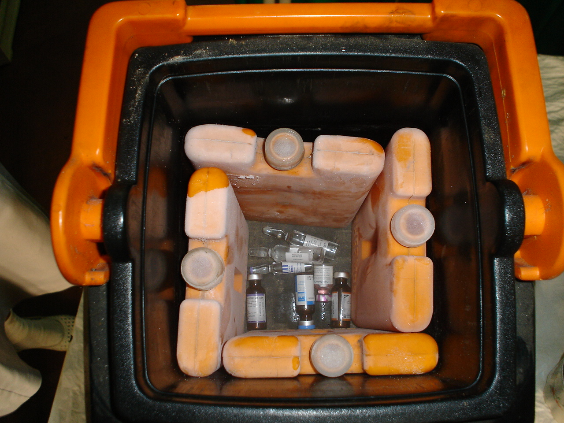
Figure 2 : Arranging ice packs in a vaccine carrier

- Do not let DPT, DT, aTd, TT , JE and Hepatitis B vaccine vials touch the ice packs. Pack these vaccine vials first in a plastic container and then place container in the vaccine carrier.

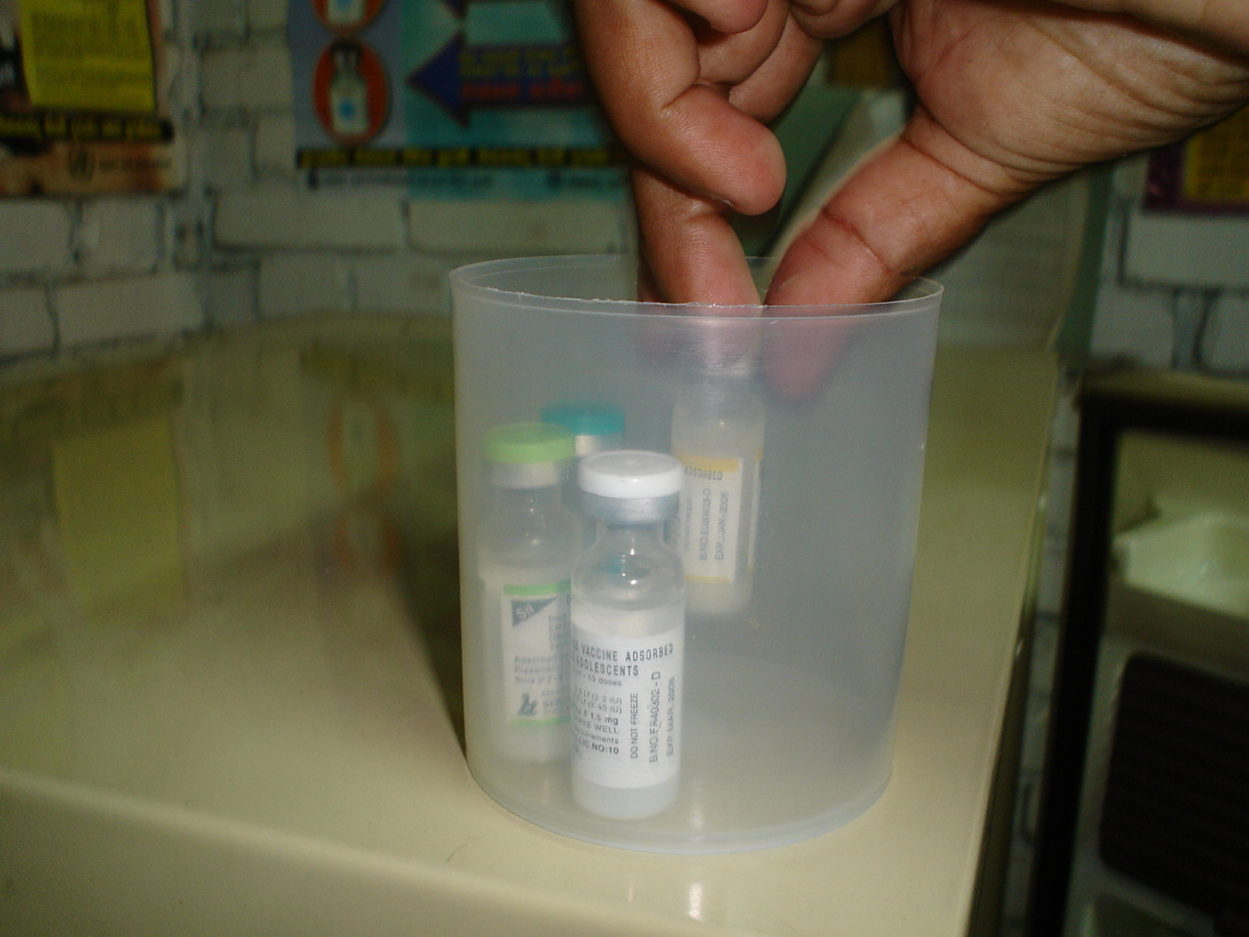
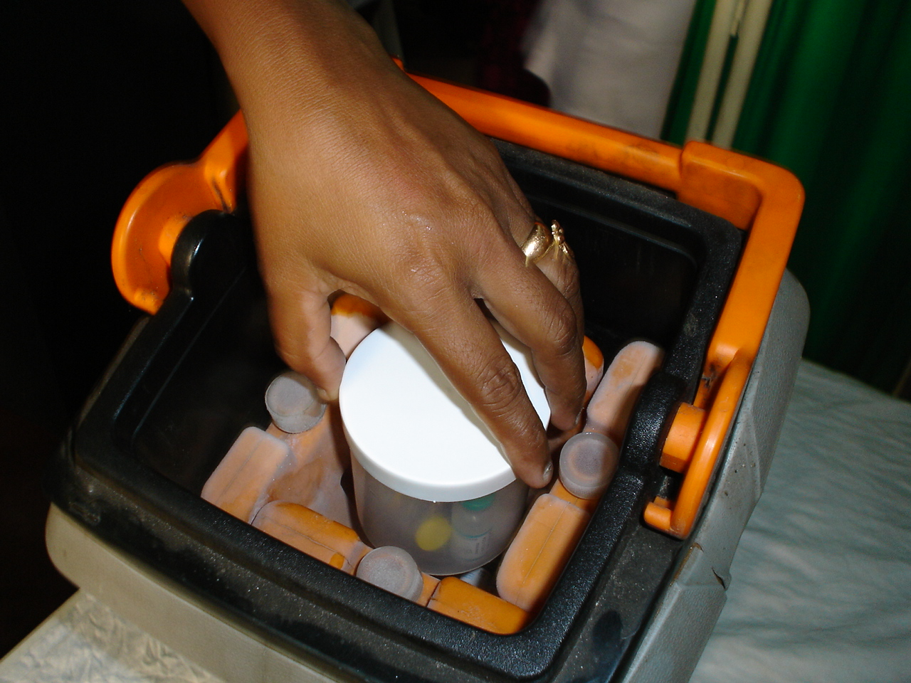

Figure 3 : Pack killed vaccine in a plastic container before place inside the vaccine carrier

- Pack ice cubes in a waterproof plastic/polythene bag before place them inside the vaccine carrier.
- Close the carrier lid tightly.

Preparation of ice packs

It takes 48 hours to freeze an ice pack.

Make ice packs as follows:

- Fill with clean cold water and put the cap on tightly.
- Hold each ice pack upside down and squeeze it to make sure that there is no leak.
- Put the ice packs upright or on their sides in the freezer and close the door.
- Leave them in the freezer for at least 48 hours to freeze solid.

Keep ice packs that do not fit in the freezer on the bottom shelf of the main section in order to keep this section cold. When you put these ice packs in to the freezer they will freeze relatively quickly because the water inside will be cold.

Remember:

You do not have to refill ice packs every time you use them. Use the same water repeatedly.
An ice pack melts quickly if not completely frozen. Make sure that the centre is frozen as well as the out side.

Maintaining the correct temperature in cold boxes and vaccine carriers

The temperature in vaccine carriers and cold boxes cannot be adjusted but you can maintain the temperature below +8⁰C if you keep heat out as follows:
- Keep the lid tightly on the vaccine carrier in transit.
- During immunization sessions, keep vaccines inside the carrier cool while providing a place to hold and protect vaccine vials in use.
- Do not put vials back inside the carrier after each use
- Keep cold boxes and vaccine carriers in the shade.
- Do not leave a cold box or vaccine carrier in a vehicle that is standing in the sun. Take it out of the vehicle and put it in the shade.

You can check whether you can still use vaccine by shaking an ice pack from the cold box or carrier. If you cannot hear water splashing, the ice pack has melted and the vaccines are not damaged. If you can hear water splashing, the ice pack has melted and the vaccines are too warm.

Remember:

In order to maintain the temperature in cold boxes and vaccine carriers:

- Keep them in the shade;
- Keep their lids on.

Vaccines are damaged by heat whether they are exposed to a lot of heat in a short time (e.g., as a result of keeping vaccine in a closed vehicle in the sun) or a small amount of heat over a long period (e.g., as a result of the frequent opening of a refrigerator door).

Damage of vaccines by freezing

DPT, DT, aTd, TT, JE and Hepatitis B vaccines can be damaged by freezing. You can find out whether this has occurred by using the shake test.

Shake test to determine whether vaccine has been frozen:

Figure 4 : Shake test to check for killed vaccines have been damaged

- Take two vials, one that you think might have been frozen and another from the same manufacturer which been frozen in the freezer for 24 hours..
- Shake both vials.
- Look at the vaccine inside the two vials (see figure 4).
- Let the sediment settle for 15-30 minutes
- Again look at the vaccine inside the two vials (see figure 4).
- If a vial fails the shake test. Dispose of it.

The tables below show the sensitivity of different vaccines to heat and freezing:
Heat sensitivity
Range | Vaccine
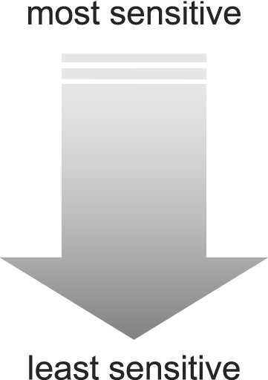 | OPV
 | Measles, MR, MMR
DTP, DTP-HepB, DTP-Hib,
DTP-HepB+Hib, YF
 | BCG
 | Hib, DT
 | Td, TT, HepB, JE
Freeze sensitivity
Range | Vaccine
 | HepB
 | Hib (liquid)
DTP, DTP-HepB, DTP-Hib,
DTP-HepB+Hib,
 | DT
 | Td
 | TT, Hib lyophilised

Light sensitivity

Finally, some vaccines are very sensitive to strong light and their exposure to ultraviolet light causes loss of potency. Consequently, they must always be protected against sunlight or fluorescent (neon) light. BCG, Measles, MR, MMR and rubella vaccines are equally sensitive to light (as well as to heat). Normally, these vaccines are supplied in vials made from dark brown glass, which gives them some protection against light damage, but care must still be taken to keep them covered and protected from strong light at all times.

Safe use of opened multi-dose vials of vaccine in subsequent immunization sessions

As part of a policy to reduce vaccine wastage, guidelines on how to continue using vials of certain vaccines (not all vaccines), once they have been opened has been in place since 2001.

The multi-dose vial policy applies only to OPV, DTP, TT, DT, Td, hepatitis B, JE Killed and liquid formulation of Hib vaccines that:

• meet WHO requirements for potency and temperature stability;

• are packaged according to International Standards Organization (ISO) standards ;

• contain an appropriate concentration of preservative such as thiomersal

Note that all above vaccines supplied through EPI programme meet these requirements.

Multi-dose vial policy (MDVP)

Multi-dose vials of OPV, DTP, TT, DT, Td, hepatitis B, Killed JE and liquid formulations of Hib vaccines from which one or more doses of vaccine have been removed during an immunization session, may be used in subsequent immunization sessions for up to a maximum of four weeks, provided that all the following conditions are met.

1. The expiry date has not passed.

2. The vaccines are stored under appropriate cold-chain conditions (+2°C to +8°C).

3. The vaccine vial septum has not been submerged in water.

4. Aseptic technique has been used to withdraw all doses.

5. The VVM, if attached, has not reached the discard point.

It is good practice to write the date of opening on vials to which the multi-dose vial policy applies, and which will be kept for use for subsequent sessions.

This policy does not change the recommended procedures for handling vaccines that must be reconstituted; for example bacille Calmette-Guérin (BCG) vaccine, measles, Rubella, MR and some formulations of Hib vaccines. Once a vial of any of these vaccines is reconstituted, it must be discarded at the end of each immunization session or at the end of six hours, whichever comes first.

